Practical - 3

Aim:
Write user defined functions for the following sorting methods and compare their performance by time measurement with random data and Sorted data.
- Selection Sort
- Bubble Sort
- Insertion Sort
- Merge Sort
- Quick Sort
- Randomized Quick Sort

Code:
#include <stdio.h>
#include <stdlib.h>

int count_steps_bubble = 0;
int count_steps_insertion = 0;
int count_steps_selection = 0;
int count_steps_quick = 0;
int count_steps_merge = 0;

// Utility function to print array
void printArray(int arr[], int n) {
for (int i = 0; i < n; i++)
printf("%d ", arr[i]);
printf("\n");
}

// 1) BUBBLE SORT
void bubbleSort(int arr[], int n) {
for (int i = 0; i < n - 1; i++) {
for (int j = 0; j < n - i - 1; j++) {
count_steps_bubble++;
if (arr[j] > arr[j + 1]) {
int temp = arr[j];
arr[j] = arr[j + 1];
arr[j + 1] = temp;
}
}
}
}

// 2) INSERTION SORT
void insertionSort(int arr[], int n) {
for (int i = 1; i < n; i++) {
int key = arr[i];
int j = i - 1;

while (j >= 0 && arr[j] > key) {
count_steps_insertion++;
arr[j + 1] = arr[j];
j--;
}
arr[j + 1] = key;
count_steps_insertion++;
}
}

// 3) SELECTION SORT
void selectionSort(int arr[], int n) {
for (int i = 0; i < n - 1; i++) {
int minIndex = i;
for (int j = i + 1; j < n; j++) {
count_steps_selection++;
if (arr[j] < arr[minIndex])
minIndex = j;
}
int temp = arr[minIndex];
arr[minIndex] = arr[i];
arr[i] = temp;
}
}

// 4) QUICK SORT
int partition(int arr[], int low, int high) {
int pivot = arr[high];
int i = low - 1;
for (int j = low; j <= high - 1; j++) {
count_steps_quick++;
if (arr[j] < pivot) {
i++;
int temp = arr[i];
arr[i] = arr[j];
arr[j] = temp;
}
}
int temp = arr[i + 1];
arr[i + 1] = arr[high];
arr[high] = temp;
return (i + 1);
}

void quickSort(int arr[], int low, int high) {
if (low < high) {
int pi = partition(arr, low, high);
quickSort(arr, low, pi - 1);
quickSort(arr, pi + 1, high);
}
}

// 5) MERGE SORT
void merge(int arr[], int l, int m, int r) {
int n1 = m - l + 1;
int n2 = r - m;
int L[n1], R[n2];
for (int i = 0; i < n1; i++) {
L[i] = arr[l + i];
count_steps_merge++;
}
for (int j = 0; j < n2; j++) {
R[j] = arr[m + 1 + j];
count_steps_merge++;
}
int i = 0, j = 0, k = l;
while (i < n1 && j < n2) {
count_steps_merge++;
if (L[i] <= R[j]) {
arr[k] = L[i];
i++;
}
else {
arr[k] = R[j];
j++;
}
k++;
}
while (i < n1) {
arr[k] = L[i];
i++;
k++;
count_steps_merge++;
}
while (j < n2) {
arr[k] = R[j];
j++;
k++;
count_steps_merge++;
}
}

void mergeSort(int arr[], int l, int r) {
if (l < r) {
int m = l + (r - l) / 2;

mergeSort(arr, l, m);
mergeSort(arr, m + 1, r);

merge(arr, l, m, r);
}
}

int main() {
int n = 0;
scanf("%d", &n);
int* array = (int*)malloc(n * sizeof(int));
for (int i = 0; i < n; i++) {
scanf("%d", &array[i]);
}
int* arr = (int*)malloc(n * sizeof(int));
for (int i = 0; i < n; i++) {
arr[i] = array[i];
}
printf("Original Array: ");
printArray(arr, n);

// Bubble Sort
int* a1 = (int*)malloc(n * sizeof(int));
for (int i = 0; i < n; i++) {
a1[i] = array[i];
}
bubbleSort(a1, n);
printf("\nBubble Sort: ");
printArray(a1, n);
printf("Number of Steps: %d\n", count_steps_bubble);

// Insertion Sort
int* a2 = (int*)malloc(n * sizeof(int));
for (int i = 0; i < n; i++) {
a2[i] = array[i];
}
insertionSort(a2, n);
printf("Insertion Sort: ");
printArray(a2, n);
printf("Number of Steps: %d\n", count_steps_insertion);

// Selection Sort
int* a3 = (int*)malloc(n * sizeof(int));
for (int i = 0; i < n; i++) {
a3[i] = array[i];
}
selectionSort(a3, n);
printf("Selection Sort: ");
printArray(a3, n);
printf("Number of Steps: %d\n", count_steps_selection);

// Quick Sort
int* a4 = (int*)malloc(n * sizeof(int));
for (int i = 0; i < n; i++) {
a4[i] = array[i];
}
quickSort(a4, 0, n - 1);
printf("Quick Sort: ");
printArray(a4, n);
printf("Number of Steps: %d\n", count_steps_quick);

// Merge Sort
int* a5 = (int*)malloc(n * sizeof(int));
for (int i = 0; i < n; i++) {
a5[i] = array[i];
}
mergeSort(a5, 0, n - 1);
printf("Merge Sort: ");
printArray(a5, n);
printf("Number of Steps: %d\n", count_steps_merge);

return 0;
}

Output:
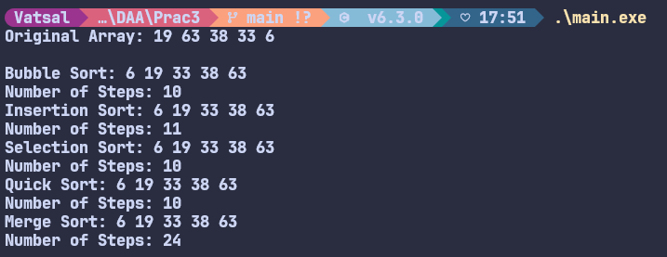

Analysis:

Random Data:
Number of Inputs | Bubble Sort | Insertion Sort | Selection Sort | Quick Sort | Merge Sort
5 | 10 | 11 | 10 | 10 | 24
10 | 45 | 32 | 45 | 20 | 68
20 | 190 | 104 | 190 | 67 | 176
30 | 435 | 263 | 435 | 110 | 296
40 | 780 | 474 | 780 | 164 | 432
50 | 1225 | 605 | 1225 | 228 | 572

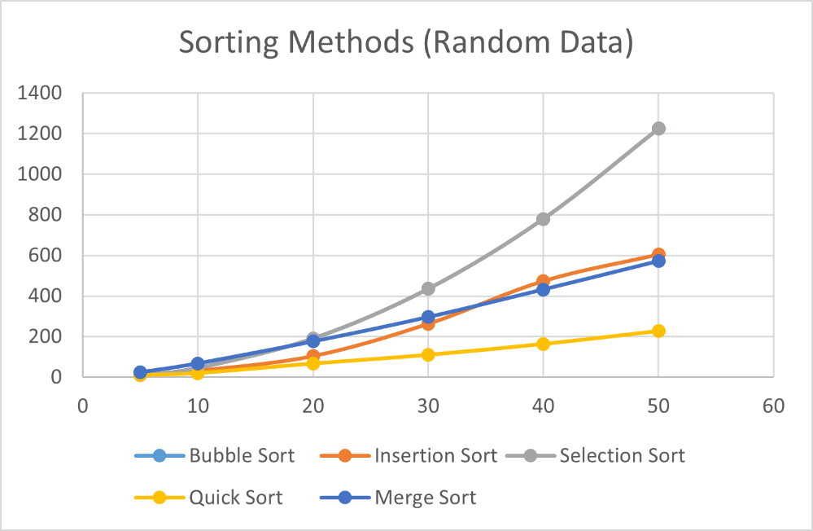

Sorted Data:
Number of Inputs | Bubble Sort | Insertion Sort | Selection Sort | Quick Sort | Merge Sort
5 | 10 | 4 | 10 | 10 | 24
10 | 45 | 9 | 45 | 45 | 68
20 | 190 | 19 | 190 | 190 | 176
30 | 435 | 29 | 435 | 435 | 296
40 | 780 | 39 | 780 | 780 | 432
50 | 1225 | 49 | 1225 | 1225 | 572

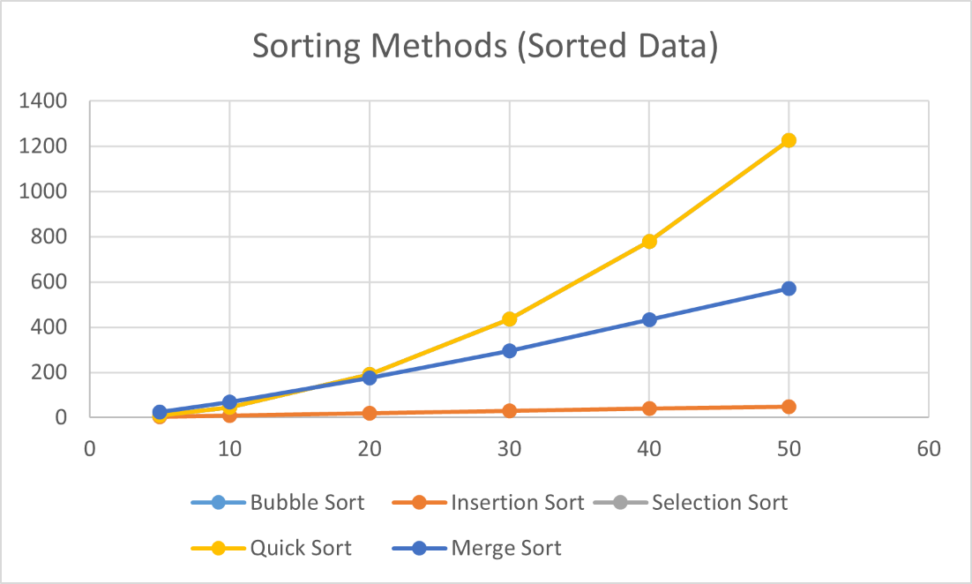

Conclusion:
it is clearly observed that different sorting algorithms exhibit significantly different performance depending on the input size and the nature of data. Simple comparison-based algorithms like Bubble Sort and Selection Sort show a rapid increase in the number of steps as the input size grows, confirming their 𝑂(𝑛²) time complexity and making them inefficient for large datasets.

Insertion Sort performs comparatively better, especially on already sorted data, where it requires minimal steps. This demonstrates its adaptive nature and efficiency for small or nearly sorted inputs.

On the other hand, Quick Sort and Merge Sort consistently perform better for larger inputs. Merge Sort shows stable performance regardless of data order due to its 𝑂 (𝑛 Log 𝑛) complexity, while Quick Sort performs very efficiently on random data but may degrade on sorted data depending on pivot selection.

Overall, this Practical validates the theoretical time complexities studied in class and highlights the importance of selecting an appropriate sorting algorithm based on input size and data characteristics rather than relying on a single method for all scenarios.

